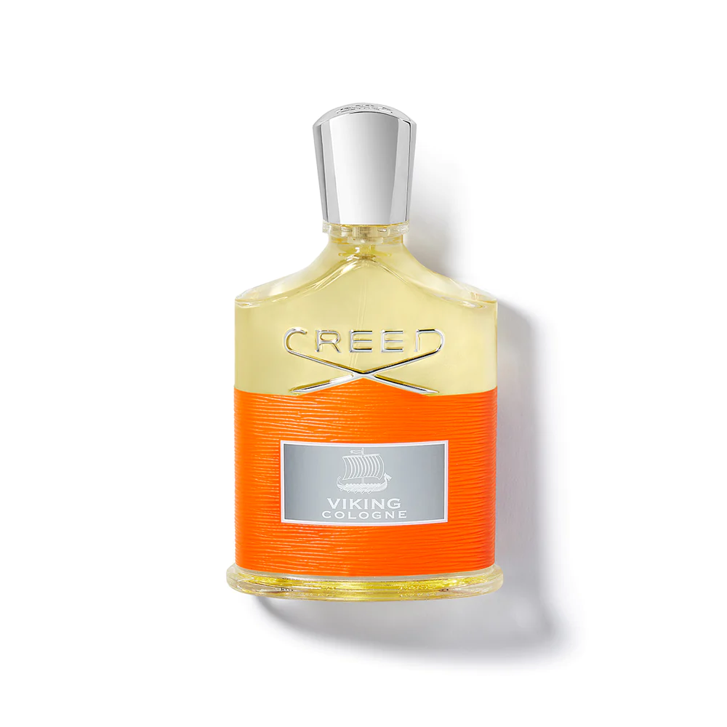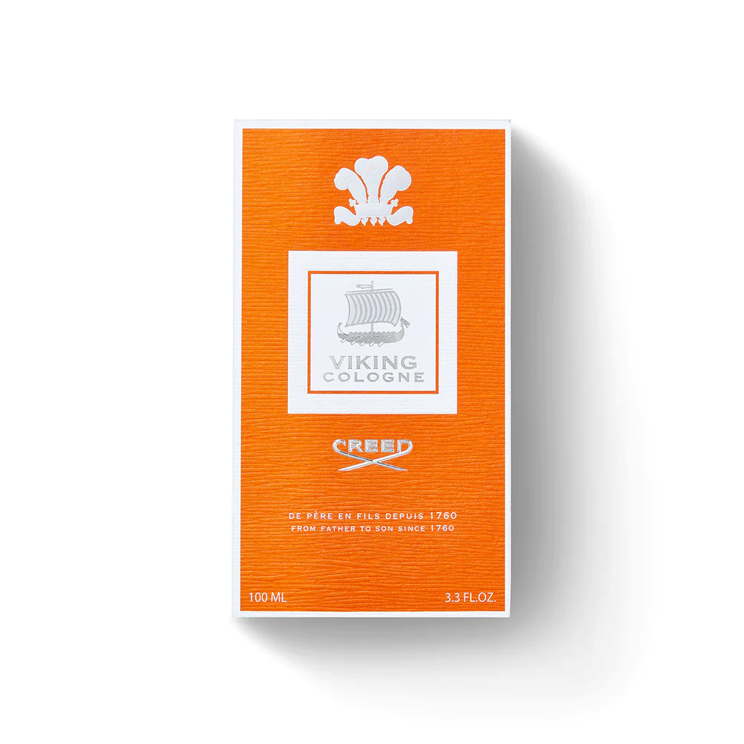

CREED VIKING COLOGNE

$495.00

Tax Included.

Spray 100 mL

IN STOCK

### Product Details

Viking Cologne is a free-spirited continuation of the dynamic Viking saga; a bracing contemporary take on an aromatic fougère that evokes the arctic sun glittering off azure fjords.

For the modern explorer, Viking Cologne bottles the pull to natural landscapes and terrains yet to be explored. Its valiant wearer is prepared to awaken adventures with undeniable perseverance. A universal fragrance of boundless exploration.